**The UDP Bandmap**

Aki Yoshida JA1NLX

To show cherry-picking process click “Show cherry-picking event viewer” in Config menu.

## Cherry-picking blocked callsign

“Show cherry-picking blocked callsigns” option.

If you right-click on the area where cherry-picked callsign is displayed then you see another menu.

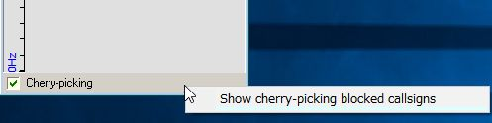

UBM_14DA2

Click “Show cherry-picking blocked callsigns” to show the table. Click “Wide” button.

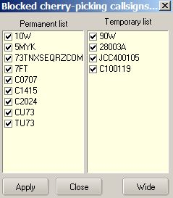

New UBM_14DA3

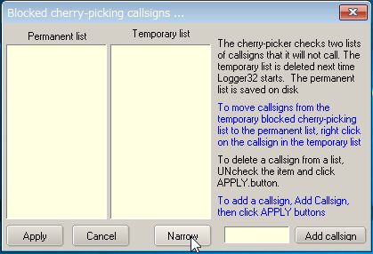

UBM_14DA4

See the text above. It explains how to add callsign you want to block and how it works.

## Drag mode:

You can now drag & drop callsigns from the UDP Bandmap into the cherry-picking blocking window. If not already open, the cherry-picking window will automatically open, once you start to drag a callsign.

You will notice the APPLY button is no longer visible unless the user wishes to make changes by UNchecking callsigns and clicking APPLY. Drag & drop changes are made automatically.  Moving a callsign from temporary to permanent makes changes automatically.

If UDP Bandmap receive text like JCC10010 73 UDP Bandmap block the call and also add it to the list of temporary blocked calls.

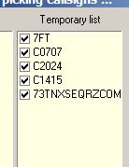

New UBM_14DA5

**Note:** Right-click on “Cherry-picking” to show menu. If you prefer then check this option.

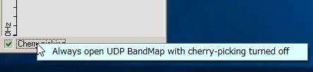

UBM_14DAB